**National Park Service CESU Proposal Procedures**

**North Atlantic Coast CESU**

Updated July 7, 2023

**Overview**

The process for soliciting and awarding a project through the CESU system involves three steps:

1. Establish Master Cooperative Agreement
2. Select the non-federal partner and principal investigator
3. Develop a research proposal and submit application
4. Establish a task agreement

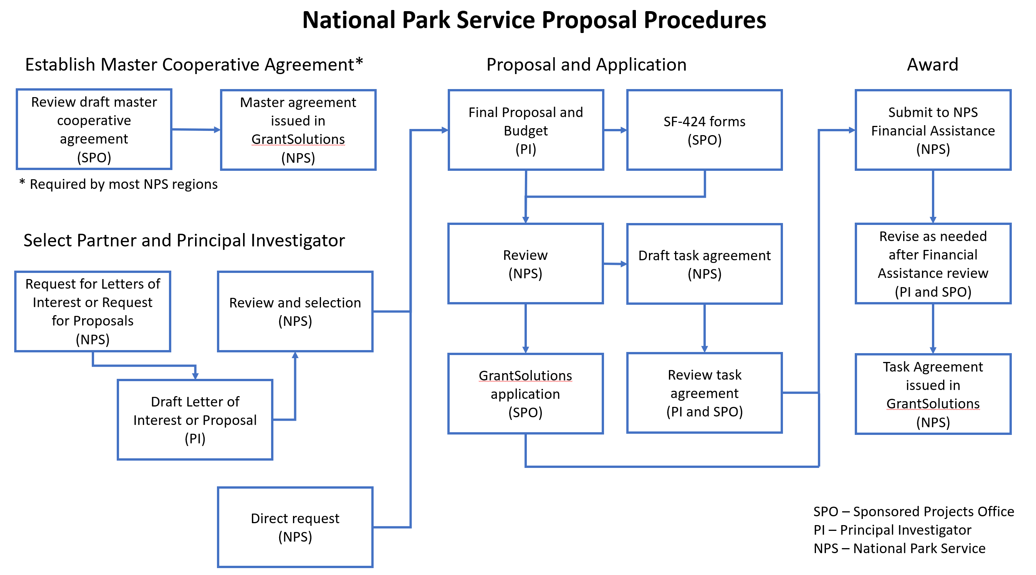

**Establish Master Cooperative Agreement**

The CESU non-federal partner generally needs to have a CESU master cooperative agreement in place with the NPS prior to any project receiving funds through a task agreement. Please contact the NPS North Atlantic Coast CESU Research Coordinator ([brian_mitchell@nps.gov](mailto:brian_mitchell@nps.gov), 404-507-5820) if you need assistance establishing a master cooperative agreement, want to determine if one is already in place, or are unsure if one is required (some NPS regions do not require a master cooperative agreement).

**Select the Non-Federal Partner and Principal Investigator**

The National Park Service (NPS) typically solicits research proposals from CESU non-federal

partners in two ways:

* Direct request – If the NPS contact is aware of a principal investigator with the appropriate expertise and experience to successfully complete the proposed project, they may reach out to the individual to discuss the project. Because many projects are awarded this way, potential principal investigators should do what they can to enhance their visibility to agency staff, including ensuring project information is up to date (with products submitted) in the [North Atlantic Coast CESU projects database](https://naccesu.uri.edu/manage-projects/), and that a profile is created in the experts database when that system is available.
* Request for Letters of Interest – If the NPS contact is unsure of which non-federal partner and principal investigators have the appropriate expertise and experience for a project, or wishes to have some level of competition for the project, they will distribute a request through one or more CESU networks
  + Requests for letters of interest are posted on the [North Atlantic Coast CESU’s web site](https://naccesu.uri.edu/funding-opportunities/) and distributed via email by the CESU Director to the CESU Technical Representatives, who in turn distribute them to all potential principal investigators
  + Letters of interest submitted in response to the request are typically 2-6 pages and the request for letters of interest will provide specific requirements. Most letters of interest contain the non-federal partner and principal investigator name and contact information, brief description of the proposed approach(es) to successfully complete the project, biographical sketch(es) of key personnel (CVs attached, and ideally including a graduate student), brief description of relevant past projects, brief description of other relevant capabilities for successfully completing the project
  + The NPS contact often creates a panel to review, rank and select the best letter of interest.

**Develop a Research Proposal and Submit Application**

Once the non-federal partner and principal investigator is selected, they should discuss the project with the NPS contact and ensure they understand the agency’s goals. Graduate student engagement with projects is strongly encouraged and will bolster the statement of public purpose. The principal investigator then develops a proposal, which usually contains the following sections:

* Header – Includes recipient name, principal investigator name and contact information, title, project dates (ideally beginning more than two months from date of submission to NPS), and amount of funding requested.
* Background/Introduction – The rationale and need for the project; clearly identify the issue to be addressed by the project. Include relevant background material and literature citations. Describe the background and qualifications of the investigator(s) as related to the scope of the proposed project.
* Purpose and Anticipated Benefits – Clearly describe the purpose of the proposed project. Discuss how the project and anticipated findings will support a public purpose (e.g., educate students, serve a community, or stimulate research) and will benefit park managers (e.g., further understanding of a resource issue, providing a new analytical tool, or providing management recommendations).
* Scope of Work and Methods – Describe the tasks that will be accomplished. Clearly describe the methods that will be used for each task and include literature citations.
* Timeline and Deliverables – Identify key project milestones and products. Include submission of project deliverables (e.g., final technical report) successively in draft and final form. Annual progress and financial reports are due within 90 days of the end of the reporting interval, which typically ends on December 31. Final reports, final financial reports, and any other products are due within 120 days of the agreement termination date.
* Budget – Provide a detailed itemized budget, including personnel (salary and fringe), travel, supplies, equipment, indirect costs (17.5% for CESU agreements), and total costs.
* Budget Justification – Clearly justify the requested cost for each budget category.
* Literature Cited – Provide a list of all citations using the [APA style](https://apastyle.apa.org/style-grammar-guidelines).

In addition to the research proposal, prepare or obtain the following documentation:

* [SF-424](https://apply07.grants.gov/apply/forms/sample/SF424_4_0-V4.0.pdf) – Application for Federal Assistance. Ensure the budget numbers on this form match the proposal.
* [SF-424A](https://apply07.grants.gov/apply/forms/sample/SF424A-V1.0.pdf) – Budget Information for Non-construction Programs. Ensure the information on this form matches your proposal.
* [SF-424B](https://apply07.grants.gov/apply/forms/sample/SF424B-V1.1.pdf) – Assurances for Non-construction Programs
* Certificate of liability insurance (only needed for the first NPS task agreement or modification in the current government fiscal year) – Something similar to [this form](https://staterisk.az.gov/sites/default/files/documents/files/COI%20Sample%20Form%20with%20HoverOver%20Instructions_1.pdf) should be provided to your organization by your insurance provider. Use the following exact information for the “Certificate Holder”: United States of America, National Park Service, 1849 C Street NW, Washington, DC 20240.
* For organizations that have spent $750k in federal funding in the previous fiscal year: Let the NPS contact know that this is the case; the NPS grant specialist will be able to obtain your organization’s Single Audit Report.
* For organizations that have not spent $750k in federal funding in the previous fiscal year:
  + Tell the NPS contact via e-mail that your organization did not expend $750k of federal funds in the previous FY and is therefore not required to complete a Single Audit.
  + Provide a copy of your organization’s most recent Independent Audit. If your organization does not have an Independent Audit, the NPS grant specialist will need to work with you and the NPS contact to complete the required Risk Assessment.

Provide your documents to the NPS contact for review. Once the NPS contact has reviewed the documents, electronically enter the project/award request into GrantSolutions (your NPS contact or Brian Mitchell ([brian_mitchell@nps.gov](mailto:brian_mitchell@nps.gov)) will be able to provide the funding opportunity number needed), including the SF-424, SF-424A, and SF-424B. GrantSolutions will generate an application number that you will provide to the NPS contact.

**Establish a Task Agreement**

The NPS contact will create a task agreement document and share the draft with you for your review. Once you approve of the language, they will submit the draft agreement and supporting documents to the NPS grants specialist for their review.

Once all approvals are in place, the PI, admin contact, and the NPS contact will be notified by GrantSolutions that the Notice of Award has been issued. Signatures are not required; your organization’s first drawdown of funds signifies acceptance of the agreement.

After you receive your Notice of Award, input information about your project into the [North Atlantic Coast CESU Projects Database](https://naccesu.uri.edu/manage-projects/). Providing your data allows the CESU to highlight your project, and could lead to additional opportunities as agency staff review existing projects to identify potential partners. Project information also helps us document our success meeting the CESU goal to support research that assists Federal agencies.